**Runtime Assertion Checking (RAC)**

Eclipse version 3.8.1

* + Once the type-checking is completed, Runtime Assertion Checking (RAC) can be performed
  + Select the RAC icon

1. PairInsertionSort

ERROR: RAC Internal Error occurred on first run against program PairInsertionSort.java

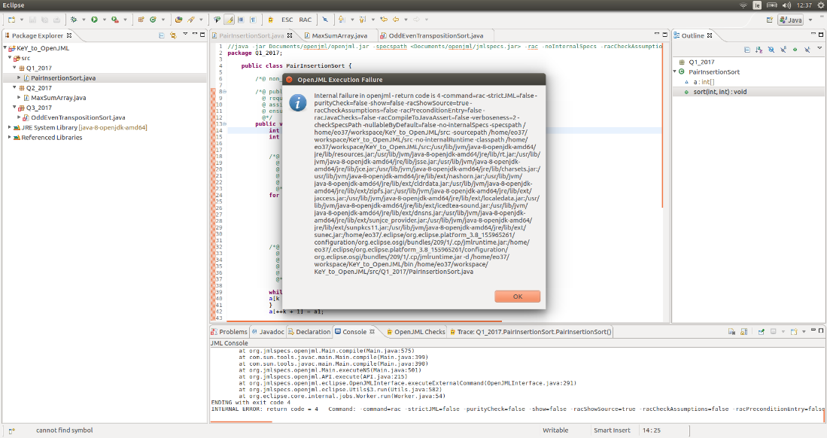

[0.00] Executing openjml on PairInsertionSort.java

error: The java environment variable openjml.eclipseSpecsProjectLocation used for testing must be defined. It should contain the absoluite path of the Specs project; you should set it as a VM argument in run Run Configuration for tests, as in -Dopenjml.eclipseSpecsProjectLocation=...

warning: Could not locate the internal specifications files - you may need to add the jmlspecs.jar explicitly on the command-line using -specspath.

warning: Could not locate the internal runtime classes - you may need to add the jmlruntime.jar explicitly on the command-line using -classpath.

RAC-Compiling Q1_2017.PairInsertionSort

Internal JML bug - please report. BuildOpenJML-20180326

java.lang.AssertionError: _JML__tmp21

at com.sun.tools.javac.comp.Lower.unbox(Lower.java:3177)

at com.sun.tools.javac.comp.Lower.boxIfNeeded(Lower.java:3136)

at com.sun.tools.javac.comp.Lower.translate(Lower.java:2382)

at com.sun.tools.javac.comp.Lower.visitBinary(Lower.java:3367)

at com.sun.tools.javac.tree.JCTree$JCBinary.accept(JCTree.java:1785)

at com.sun.tools.javac.tree.TreeTranslator.translate(TreeTranslator.java:58)

at com.sun.tools.javac.comp.Lower.translate(Lower.java:2371)

at com.sun.tools.javac.comp.Lower.translate(Lower.java:2382)

at com.sun.tools.javac.comp.Lower.visitVarDef(Lower.java:3547)

at com.sun.tools.javac.tree.JCTree$JCVariableDecl.accept(JCTree.java:852)

at org.jmlspecs.openjml.JmlTree$JmlVariableDecl.accept(JmlTree.java:1284)

at com.sun.tools.javac.tree.TreeTranslator.translate(TreeTranslator.java:58)

at com.sun.tools.javac.comp.Lower.translate(Lower.java:2371)

at com.sun.tools.javac.tree.TreeTranslator.translate(TreeTranslator.java:70)

at com.sun.tools.javac.tree.TreeTranslator.visitBlock(TreeTranslator.java:162)

at com.sun.tools.javac.comp.Lower.visitBlock(Lower.java:3561)

at com.sun.tools.javac.tree.JCTree$JCBlock.accept(JCTree.java:909)

at org.jmlspecs.openjml.JmlTree$JmlBlock.accept(JmlTree.java:1227)

at com.sun.tools.javac.tree.TreeTranslator.translate(TreeTranslator.java:58)

at com.sun.tools.javac.comp.Lower.translate(Lower.java:2371)

at com.sun.tools.javac.comp.Lower.visitWhileLoop(Lower.java:3573)

at com.sun.tools.javac.tree.JCTree$JCWhileLoop.accept(JCTree.java:965)

at org.jmlspecs.openjml.JmlTree$JmlWhileLoop.accept(JmlTree.java:1716)

at com.sun.tools.javac.tree.TreeTranslator.translate(TreeTranslator.java:58)

at com.sun.tools.javac.comp.Lower.translate(Lower.java:2371)

at com.sun.tools.javac.tree.TreeTranslator.translate(TreeTranslator.java:70)

at com.sun.tools.javac.tree.TreeTranslator.visitBlock(TreeTranslator.java:162)

at com.sun.tools.javac.comp.Lower.visitBlock(Lower.java:3561)

at com.sun.tools.javac.tree.JCTree$JCBlock.accept(JCTree.java:909)

at org.jmlspecs.openjml.JmlTree$JmlBlock.accept(JmlTree.java:1227)

at com.sun.tools.javac.tree.TreeTranslator.translate(TreeTranslator.java:58)

at com.sun.tools.javac.comp.Lower.translate(Lower.java:2371)

at com.sun.tools.javac.tree.TreeTranslator.translate(TreeTranslator.java:70)

at com.sun.tools.javac.tree.TreeTranslator.visitBlock(TreeTranslator.java:162)

at com.sun.tools.javac.comp.Lower.visitBlock(Lower.java:3561)

at com.sun.tools.javac.tree.JCTree$JCBlock.accept(JCTree.java:909)

at org.jmlspecs.openjml.JmlTree$JmlBlock.accept(JmlTree.java:1227)

at com.sun.tools.javac.tree.TreeTranslator.translate(TreeTranslator.java:58)

at com.sun.tools.javac.comp.Lower.translate(Lower.java:2371)

at com.sun.tools.javac.tree.TreeTranslator.visitTry(TreeTranslator.java:218)

at com.sun.tools.javac.comp.Lower.visitTry(Lower.java:3897)

at com.sun.tools.javac.tree.JCTree$JCTry.accept(JCTree.java:1173)

at com.sun.tools.javac.tree.TreeTranslator.translate(TreeTranslator.java:58)

at com.sun.tools.javac.comp.Lower.translate(Lower.java:2371)

at com.sun.tools.javac.tree.TreeTranslator.translate(TreeTranslator.java:70)

at com.sun.tools.javac.tree.TreeTranslator.visitBlock(TreeTranslator.java:162)

at com.sun.tools.javac.comp.Lower.visitBlock(Lower.java:3561)

at com.sun.tools.javac.tree.JCTree$JCBlock.accept(JCTree.java:909)

at org.jmlspecs.openjml.JmlTree$JmlBlock.accept(JmlTree.java:1227)

at com.sun.tools.javac.tree.TreeTranslator.translate(TreeTranslator.java:58)

at com.sun.tools.javac.comp.Lower.translate(Lower.java:2371)

at com.sun.tools.javac.tree.TreeTranslator.visitMethodDef(TreeTranslator.java:145)

at com.sun.tools.javac.comp.Lower.visitMethodDefInternal(Lower.java:2828)

at com.sun.tools.javac.comp.Lower.visitMethodDef(Lower.java:2737)

at com.sun.tools.javac.tree.JCTree$JCMethodDecl.accept(JCTree.java:778)

at org.jmlspecs.openjml.JmlTree$JmlMethodDecl.accept(JmlTree.java:1158)

at com.sun.tools.javac.tree.TreeTranslator.translate(TreeTranslator.java:58)

at com.sun.tools.javac.comp.Lower.translate(Lower.java:2371)

at com.sun.tools.javac.comp.Lower.visitClassDef(Lower.java:2508)

at com.sun.tools.javac.tree.JCTree$JCClassDecl.accept(JCTree.java:693)

at org.jmlspecs.openjml.JmlTree$JmlClassDecl.accept(JmlTree.java:1074)

at com.sun.tools.javac.tree.TreeTranslator.translate(TreeTranslator.java:58)

at com.sun.tools.javac.comp.Lower.translate(Lower.java:2371)

at com.sun.tools.javac.comp.Lower.translate(Lower.java:2390)

at com.sun.tools.javac.comp.Lower.translateTopLevelClass(Lower.java:3932)

at com.sun.tools.javac.main.JavaCompiler.desugar(JavaCompiler.java:1522)

at org.jmlspecs.openjml.JmlCompiler.desugar(JmlCompiler.java:434)

at com.sun.tools.javac.main.JavaCompiler.compile2(JavaCompiler.java:898)

at org.jmlspecs.openjml.JmlCompiler.compile2(JmlCompiler.java:674)

at com.sun.tools.javac.main.JavaCompiler.compile(JavaCompiler.java:867)

at com.sun.tools.javac.main.Main.compile(Main.java:553)

at com.sun.tools.javac.main.Main.compile(Main.java:410)

at org.jmlspecs.openjml.Main.compile(Main.java:575)

at com.sun.tools.javac.main.Main.compile(Main.java:399)

at com.sun.tools.javac.main.Main.compile(Main.java:390)

at org.jmlspecs.openjml.Main.executeNS(Main.java:501)

at org.jmlspecs.openjml.API.execute(API.java:215)

at org.jmlspecs.openjml.eclipse.OpenJMLInterface.executeExternalCommand(OpenJMLInterface.java:291)

at org.jmlspecs.openjml.eclipse.Utils$3.run(Utils.java:582)

at org.eclipse.core.internal.jobs.Worker.run(Worker.java:54)

ENDING with exit code 4

ENDING with exit code 4

INTERNAL ERROR: return code = 4 Command: -command=rac -strictJML=false -purityCheck=false -show=false -racShowSource=true -racCheckAssumptions=false -racPreconditionEntry=false -racJavaChecks=false -racCompileToJavaAssert=false -verboseness=2 -checkSpecsPath -nullableByDefault=false -no-internalSpecs -specspath /home/eo37/workspace/KeY_to_OpenJML/src: -sourcepath /home/eo37/workspace/KeY_to_OpenJML/src -no-internalRuntime -classpath /home/eo37/workspace/KeY_to_OpenJML/src:/usr/lib/jvm/java-8-openjdk-amd64/jre/lib/resources.jar:/usr/lib/jvm/java-8-openjdk-amd64/jre/lib/rt.jar:/usr/lib/jvm/java-8-openjdk-amd64/jre/lib/jsse.jar:/usr/lib/jvm/java-8-openjdk-amd64/jre/lib/jce.jar:/usr/lib/jvm/java-8-openjdk-amd64/jre/lib/charsets.jar:/usr/lib/jvm/java-8-openjdk-amd64/jre/lib/ext/nashorn.jar:/usr/lib/jvm/java-8-openjdk-amd64/jre/lib/ext/cldrdata.jar:/usr/lib/jvm/java-8-openjdk-amd64/jre/lib/ext/zipfs.jar:/usr/lib/jvm/java-8-openjdk-amd64/jre/lib/ext/jaccess.jar:/usr/lib/jvm/java-8-openjdk-amd64/jre/lib/ext/localedata.jar:/usr/lib/jvm/java-8-openjdk-amd64/jre/lib/ext/icedtea-sound.jar:/usr/lib/jvm/java-8-openjdk-amd64/jre/lib/ext/dnsns.jar:/usr/lib/jvm/java-8-openjdk-amd64/jre/lib/ext/sunjce_provider.jar:/usr/lib/jvm/java-8-openjdk-amd64/jre/lib/ext/sunpkcs11.jar:/usr/lib/jvm/java-8-openjdk-amd64/jre/lib/ext/sunec.jar:/home/eo37/.eclipse/org.eclipse.platform_3.8_155965261/configuration/org.eclipse.osgi/bundles/209/1/.cp/jmlruntime.jar:/home/eo37/.eclipse/org.eclipse.platform_3.8_155965261/configuration/org.eclipse.osgi/bundles/209/1/.cp/jmlruntime.jar -d /home/eo37/workspace/KeY_to_OpenJML/bin /home/eo37/workspace/KeY_to_OpenJML/src/Q1_2017/PairInsertionSort.java

1. MaxSumArray
   * No error when RAC is run against MaxSumArray.java (Unknown reason for error with first program)

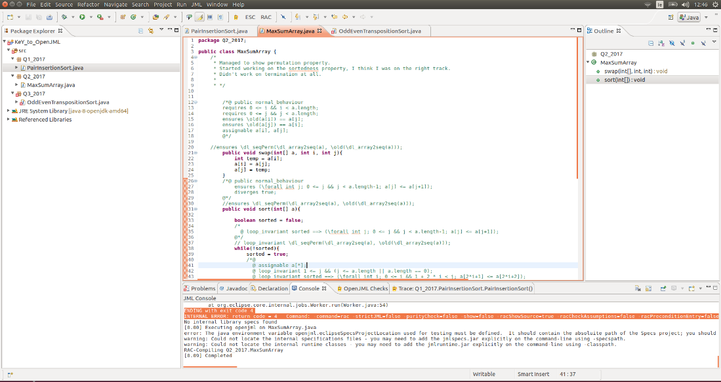

[0.00] Executing openjml on MaxSumArray.java

error: The java environment variable openjml.eclipseSpecsProjectLocation used for testing must be defined. It should contain the absoluite path of the Specs project; you should set it as a VM argument in run Run Configuration for tests, as in -Dopenjml.eclipseSpecsProjectLocation=...

warning: Could not locate the internal specifications files - you may need to add the jmlspecs.jar explicitly on the command-line using -specspath.

warning: Could not locate the internal runtime classes - you may need to add the jmlruntime.jar explicitly on the command-line using -classpath.

RAC-Compiling Q2_2017.MaxSumArray

[0.09] Completed

**Command Line**

* -rac option

1. PairInsertionSort
   * ERROR: RAC Error when run on program PairInsertionSort.java

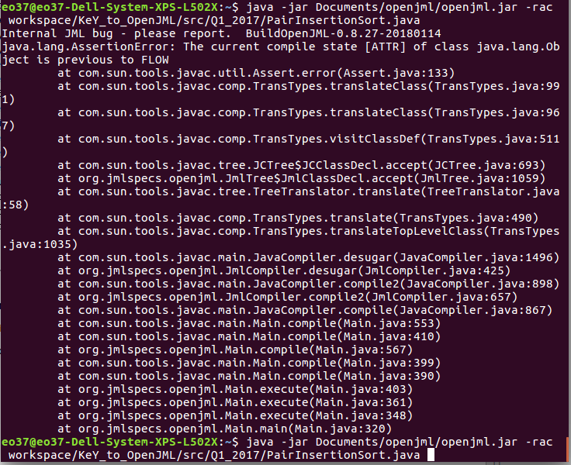

1. MaxSumArray
   * ERROR: RAC Error when run on program MaxSumArray.java

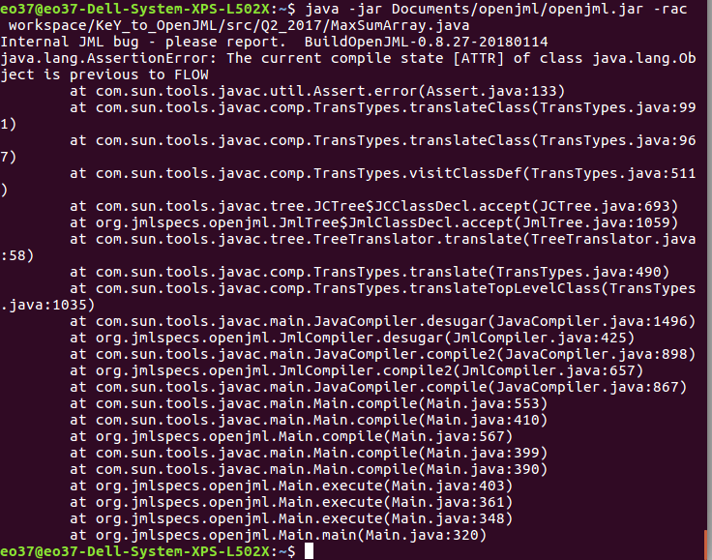

* -rac -noInternalSpecs -racCheckAssumptions options

1. PairInsertionSort
   * ERROR: RAC Error when run on program PairInsertionSort.java

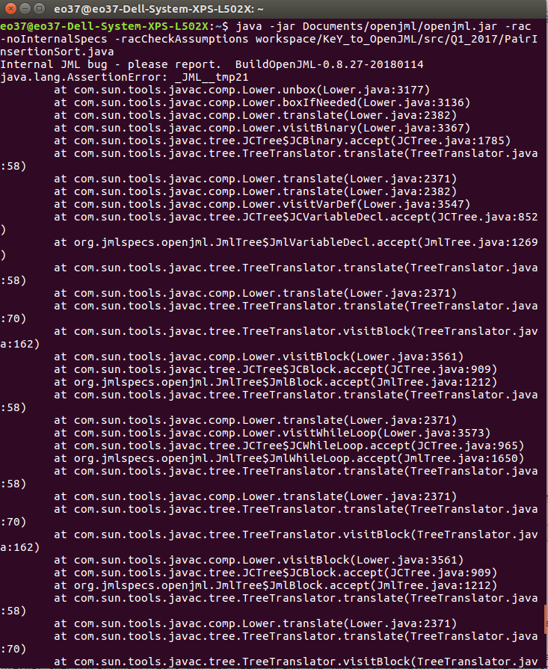

1. MaxSumArray
   * No error when run on program MaxSumArray.java
   * However, again no message to say RAC completed and was successful



NOTE:

* Inserting the specspath again removes all errors but unknown as to why and what is happening

